Make cursor pointer look

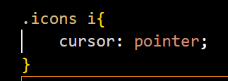

big icon : add fa-2x or fa-3s – (as per requirement size)

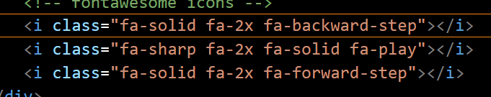

Font awesome is used to get icon via CDN

<https://fontawesome.com/search?q=forward%20step&o=r>

when background image is not be blur that time apply below container apply background image upper take one more container they will do blue like below images

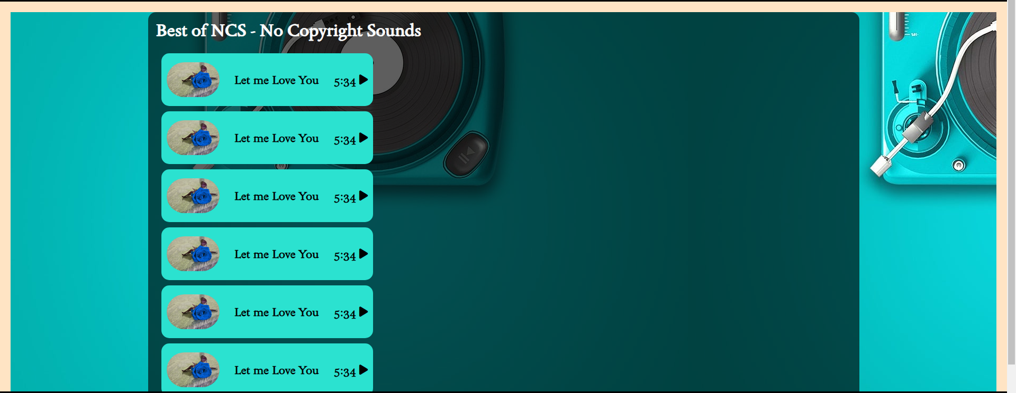

After clicking right click inspect you can change style in chrome and them after change and say that test you can apply those change in your code

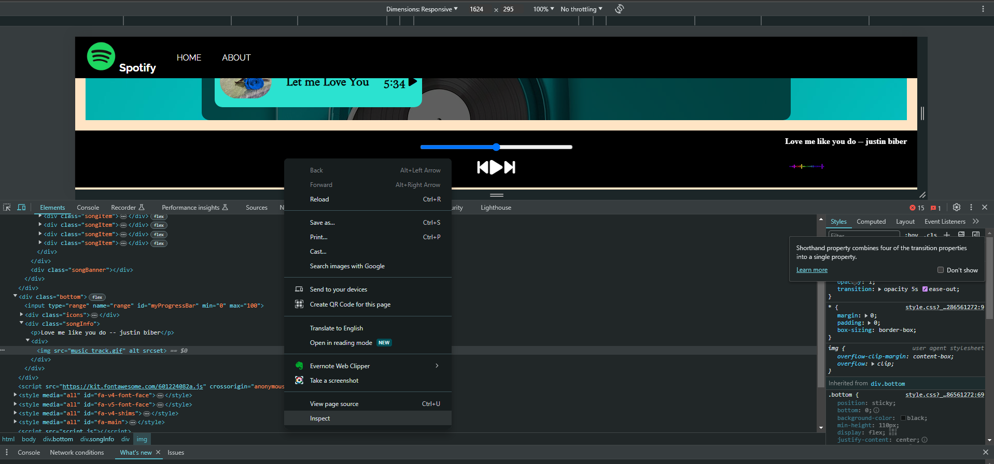

When you write first your js code your test they running or not test by below method

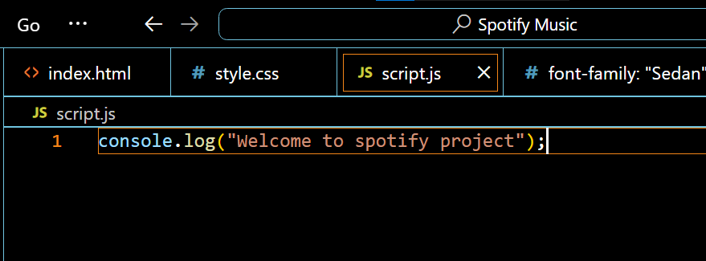

Percentage = current/duration \* 100;

Current= percentage \* duration/100

Below click on change all document it will same like upper select part change

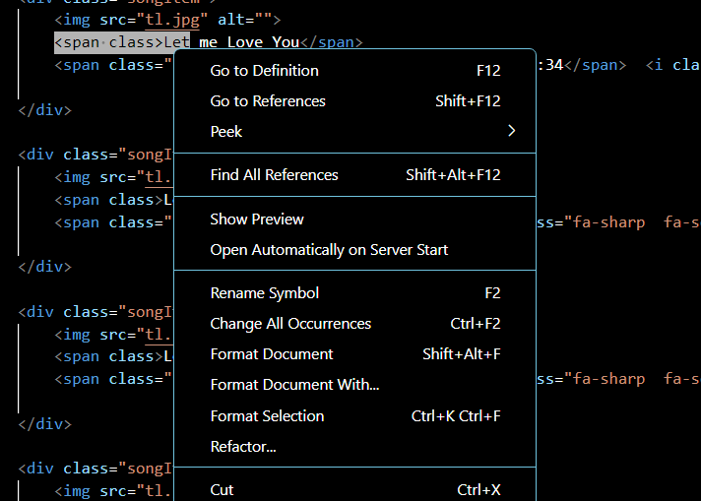

Array Collection

